CFS3 New Theater detailed tutorial
odin_br – aug 2016 – v0.1
Objective
Following steps you will generate a totally new theater on CFS3. The theater generated can be used for research and development of new scenerys for CFS3.
Tools and apps
- Non modified CFS3.1 installed and running.
- CFS3 Terrain SDK tools installed and running (Read Landclass, Mesh and water sections of Terrain SDK).
- make_water.zip (downloaded from SOH site)
- Global Mapper 16 (GM) or Above – payware – 30 days evaluation (http://www.bluemarblegeo.com/products/global-mapper.php)
- Photoshop 6 or Above – payware
- QGIS - Freeware ( http://www.qgis.org/en/site/)
- Irfanview – Freeware
- MultiCFS3.exe -Freeware - http://www.mwgfx.co.uk/ - See at CFS3 – Utilities section
- CFS3_math.xls – Excel file on KIT CFS3 NEW THEATER
- Winrar or Winzip
Step 0 (Zero) - New CFS3 copy and working directory creation.
0.1-) Start your new theater creating a subdirectory on the local that you choose to create a new theater. Use an easy name with 3 or 4 chars. For this tutorial, I used WAW (World at War).
0.2-) Copy all files and subdiretories of your original CFS3 root dir and paste to your new theater dir.
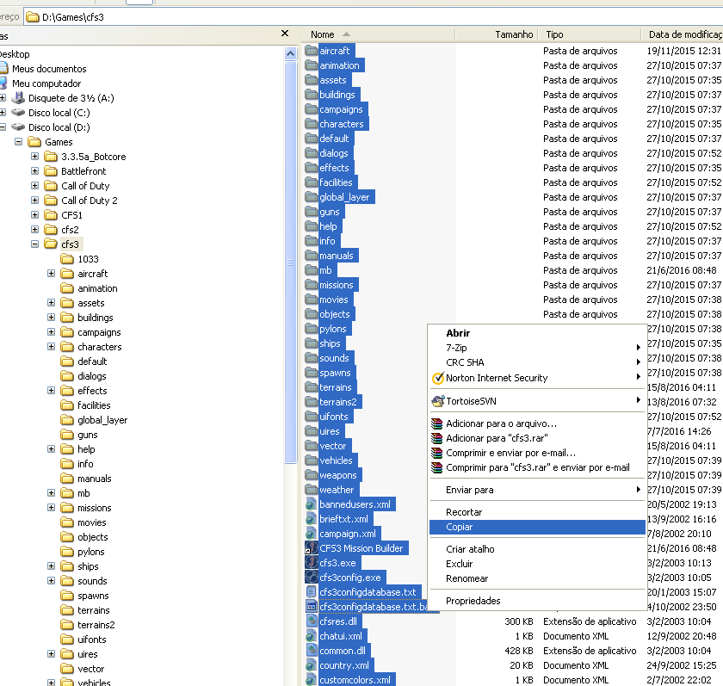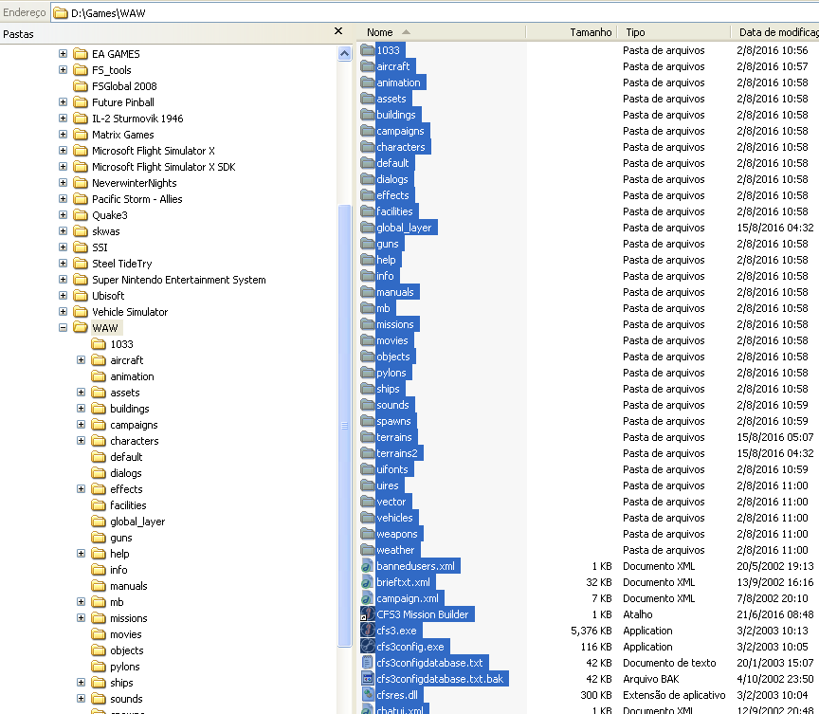
Original Install
New Theater copy

0.3-) Copy the MultiCFS3.exe to your new theater root dir.
0.4-) Execute the MultiCFS3 and write the name of your new theater on text box and click accept.
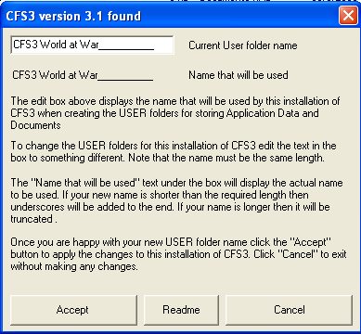
0.5-) Now, execute your new theater copied installation and check it with free flight, if it’s all ok. If yes go to 0.6 step.
0.6-) Check if Multicfs3 created a personal cfs3 files:
On Windows XP
Documents and Settings\<username>\Application Data\Microsoft\<your theater name>
and
Documents and Settings\<username>\My Documents\<your theater name>
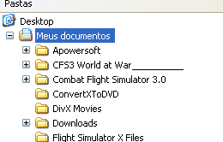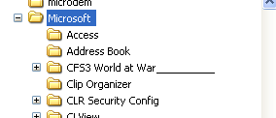
On Windows Vista and above
Users\<user name>\Documents\<your theater name>
and
Users\<user name>\AppData\Roaming\Microsoft\<your theater name>

If yes, go to 0.7.
0.7-) Now, create a directory on the root of your drive C. Name it with a short and easy name (this tutorial uses a c:\cfs3t). Copy all files of a CFS3 terrain SDK\Tools subdir, into it.
Copy the CFS3 Terrain SDK\ Global Layer subdir into it.
Extract make_water.zip (downloaded from SOH) into it.
Also, copy the cfs3_math.xls, c2v.txt and landclasses.xml files from KIT. Your working dir must be like following figure:
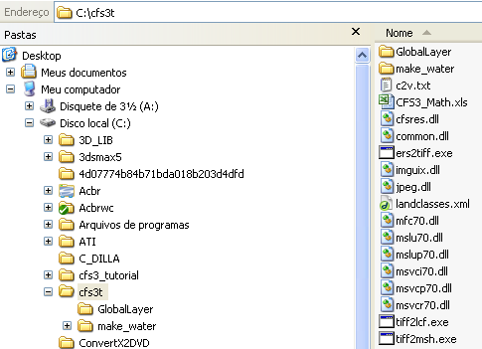
0.8-) END OF STEP ZERO

